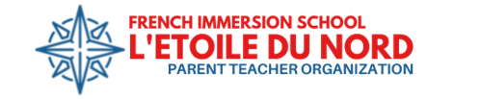PTO General Meeting Agenda
November 13, 2025, 6:00-7:00 pm
6:00 pm Welcome from PTO President, Rebekah LaCasse
6:02 pm Read meeting norms and procedures

6:05 pm Principal's Update - Andrew Barter

6:10 pm Social Committee - Anna Larson
- Carnaval des Citrouilles Follow-Up
- Staff Appreciation Meals Follow-Up
- Open Gym and Community Potluck, Tuesday Nov. 28th 6-8pm

6:40 pm Intern Committee-Rebekah LaCasse
- Social Outings
- Hosting ‘26-27
- Intern Recruitment

6:45 pm Communications Committee-Malia Caruso
- Book Fair Update
- Spirit Gear Order
- PTO School Directory App

6:50 pm Fundraising Committee-Rebekah LaCasse
- Davanni’s Fundraiser Follow-Up
- Direct Donation Campaign Results
- Give to the MAX! November 20th

6:55 pm Treasurer’s Update - Sarah Canfield
- Budget Revision Review and Ideas

7:00 pm PTO Meeting Adjournment-Join us for our next meeting on December 11th!
- Community Input for December PTO Meeting Topics
  - Email suggestions to malia.caruso@lnfi-pto.org or use QR code on next month’s flier
Join our November meeting:
https://zoom.us/j/99974585262?pwd=qY5sdFnqa45l6zVirjIbAY0F1va7mQ.1


