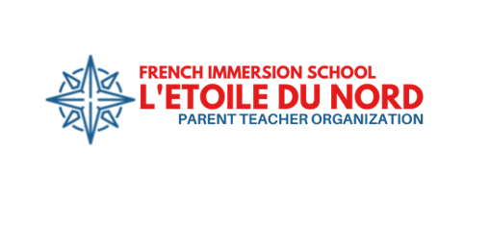

L’Etoile du Nord PTO 2024-2025 Donation Appeal

Dear L’Etoile du Nord Families,

Bonjour! Welcome to a new school year full of fun and learning! We are writing to ask that you invest in our children’s learning by making a donation to the L’Etoile du Nord Parent Teacher Organization. The money we raise goes right back to students, teachers, and interns – to help our students become life-long learners who are successful in a global, multilingual community.

This year, we are welcoming French-speaking interns to work with our students and teachers. They bring their energy, language, and culture to our school, and help our students learn and grow. The PTO pays for these interns and PTO volunteers make the intern program run. The PTO also sponsors community events such as Open Gym and BIPOC Support Group. We provide funding for school enrichment such as the Afoutayi dance residency, and we provide appreciation meals and events for the amazing people who serve our students everyday.

We have sent home a donation card and envelope with each student. We ask that you complete the card, and return the card and envelope to your student’s classroom by Friday, October 11, 2024. Teachers will have a box to receive completed cards in each classroom.

The cards ask you to make a donation to the L’Etoile du Nord PTO. You can make a donation online ([www.lnfi-pto.org](http://www.lnfi-pto.org), click on “Contribute”) or by check or cash. The suggested donation is $125 per student. You can make a one-time donation or set up recurring monthly donations. Meanwhile, back at school, students will receive fun prizes based on the number of completed donation cards received in each classroom – e.g., glow sticks, mini bubbles, extra recess!

Please join me in supporting our students, teachers, and interns with a donation. Many corporations will offer a donation match, so please take a moment to check your company’s policy! Help our students have fun while making their future as bright as it can be.

Thank you in advance for your donations. Merci!

The L’Etoile du Nord PTO Executive Board

P.S. Your participation is what matters most! Please complete and return your donation card.

Classrooms win prizes based on the number of returned donation cards, regardless of donation.

About the 2024-2025 PTO Budget and Direct Donations

How much money does the PTO hope to raise through direct donations this year?

Our goal is to raise $12,500 dollars through direct donations during the 2023-2024 school year. The suggested donation amount is $125 per student.

How do direct donations fit with the PTO budget and fundraising?

Our goal is to raise at least $52,100 dollars this year. We anticipate that direct donations will make up about one-fourth of PTO funds. Here is a breakdown of our fundraising goals:

| **2024-2025**  **Fundraising Goals** | |
| --- | --- |
| Individual Donations | $12,500 |
| Corporate Matching Donations | $5,000 |
| Fun Run | $20,000 |
| Kermesse | $5,000 |
| Fall Carnival | $2,500 |
| Spirit Wear | $2,000 |
| Give to the Max Day | $1,000 |
| Plant Sale | $2,000 |
| Restaurant Night | $500 |
| Box Tops | $100 |
| Book Fair | $1500 |
| **Total** | $52,100 |

Does the goal of $12,500 take into account that some families cannot make a donation?

Yes, it does. We realize that not every family will be able to make the suggested donation. Even if you cannot make a donation, please complete and return your donation card so that your student’s classroom can win fun prizes.

Have LNFI families expressed support for making direct donations?

Yes. In our spring 2024 survey, many families indicated that the Direct Donation Campaign was their preferred fundraiser. With direct donations, the PTO gets over 95 percent of your donation (after transaction fees). We get 100 percent of your check and cash donations.